Detecting, Mapping, and Grading Sidewalks using Street View Images and Secondary Sources for the city of Dallas

Andrew Abbott1, Alex Deshowitz1, Dennis Murray1, Dr. Eric Larson1

1 Southern Methodist University, Dallas, Texas

**Abstract.** The United States Census identified that 19% of the population in 2012 had some type of disability, with total citizens with disabilities totaling more than fifty-six million people. Features such as curb ramps are often much more important in the planning of a route for the mobility challenged. In this research, machine learning methods were used to identify curb ramps in “Street View” images. The data developed from this task would create another layer of geo-coded data that could be added to maps and their metadata. The image dataset consists of 18,000 panoramic street view images, with a “matching bounding box” dataset that identifies the location of curb cuts. In total, the data consists of more than 40,000 examples of the actual locations of curb ramps as well as locations where curb ramps are expected. We used a convolutional neural network to identify the presence of curb ramps in the Project Sidewalk images, and benchmarked the performance against a logistic regression model. The Convolutional Neural Network based approach was more accurate, and faster to train, than a logistic regression approach. The Logistic Regression approach achieved a 67% accuracy on the data set, while the CNN approach achieved an 80% accuracy in classification of a cropped image. A further step was taken to train a TensorFlow object detection algorithm to find curb ramps within the broader panoramic StreetView image. Based on the outcomes of the modeling, a novel qualitative scoring model called QSI (Quality Sidewalk Index) was developed to provide information about the availability of curb cuts on a block by block basis within a city.

1 Introduction

For individuals with mobility limitations, the availability of sidewalks with quality curb ramps represents a necessity in navigating a city or urban environment. In the absence of this information wheelchair users are forced to rely on their own experience and knowledge of a specific area to successfully navigate to their destination in an efficient and safe manner. Without this navigability knowledge, a wheelchair user may choose to take much longer routes or could sustain serious injuries on a route without ramps, or may choose not to travel at all. Previous attempts at identifying curb cuts have been carried out through in-person (subjective) “Neighborhood Audits” or through information cataloged in Geographic Information Systems [18]. The completeness, timeliness, and quality of the information gathered in these methods is often lower than what is needed for a comprehensive view of of navigation features including curb ramps or sidewalks across a city. These manual approaches also tend to come with a very high cost of acquisition.

There is a myriad of reasons for the city of Dallas to focus a portion of spending on sidewalk creation and repair. For the mobility impaired, availability of sidewalks is an essential requirement for moving about the metropolitan area. Additionally, sidewalks allow citizens to move in a safe manner around the city without the risks associated with walking in the streets amongst cars driven by ever-increasingly distracted drivers. Sidewalks also provide health benefits since they provide a means of pedestrian travel to near-home destinations for those who may otherwise choose to not travel. Sidewalks in disrepair tend to contribute to the “broken-windows” theory surrounding many under-privileged areas of the metroplex. Overall, sidewalks represent a worthwhile investment for the city and provide a means of safe and healthy travel for those who choose pedestrian transportation.

Despite the obvious benefits of accessibility to a city and its citizens, the problem of documenting and mapping current levels of accessibility is persistent. This represents an issue for the city in the proper allocation of resources to different parts of the city. It also represents an issueto the citizens and visitors: difficulty navigating the city due to gaps in the availability of sidewalks and curb ramps for mobility impaired citizens.

In the fiscal year 2015, Dallas had a proposed budget for infrastructure projects, such as sidewalks, of $7,135,208. That number has grown each of the past several years as the city has increased in size. The city of Dallas has grown in both its inhabited sprawl and in the density of the population at double-digit rates over the past 5 years. This growth can be explained by the city’s pro-business mentality and the relative value proposition that such a large city provides. Dallas boasts a centrally located position in the country, and the city’s status as a transportation hub allows businesses to send employees to any destination in the world with relative ease and efficiency. The city and state have pro-business tax and incentive policies, that have encouraged this growth. With this growth, the city must acquire a better way of allocating the budget for sidewalks and other infrastructure.

Today, the city of Dallas responds to complaints about sidewalks through its street services program. As incidents are received, the city will place the inquiry on a list for assessment. There is no priority granted for severity of the situation, thus, all incidents are treated with the same level of priority. The data set generated from these requests is available via the Dallas Open Data platform, but there is no indication that any regard is given based on the number of requests from an area of the city Additionally, maintenance in suburban areas is the responsibility of the home or property owner and this is not necessarily considered in the ranking process. The current process takes 2-3 months in order to get an assessment and cost estimate for each incident or property owner. Once the assessment has been done, either the city or the property owner will plan and fund the project. One program in Dallas allows the city to reimburse homeowners up to $500 or 50% of the repair cost, whichever is less.

Under these circumstances, the city spends significant time and resources just completing the assessments. Using the methods described in this paper, the city could determine the existing locations of curb ramps across the entire urban environment. With the knowledge of home addresses and common destinations of the DART Paratransit network, officials could place resources against zones of the city that lack in infrastructure with a population that requires the use of curb ramps;

To rectify the lack of city-wide mapping of curb cuts, this paper demonstrates a machine learning based solution. Using a data set of images and coordinates of curb cuts within the images, several machine learning methods were evaluated for accuracy in detecting curb cuts in a sidewalk.

The data set of labeled images were partitioned to “training” and “test” images using a ratio of 80% to train, and 20% to test using a random selection mechanism. The test images were held blind from the modeling process. As a baseline, a logistic regression model was built and achieved 67% accuracy on the test data set. The trained Convolutional Neural Network achieved 80% accuracy on the same test image set.

As a demonstration of generalization of the concept, a TensorFlow object detection model was trained for identification of curb cuts within a panoramic image.

A method to extend the trained model to the full geography of the city of Dallas is also outlined. Additionally, we suggest an approach to leveraging this model to make sound recommendations regarding areas of focus for the city planning commission.

Section 2 of this paper will highlight related work that helped direct the creation of the solution. Section 3 will explain convolutional neural networks. Section 4 will discuss the algorithms, and section 5 will outline the results of the tests. Section 6 addresses ethical considerations of the research, and section 7 provides a path to future implementation of this research in municipal operations.

2 Related Work

The current reach of accessibility features in the urban landscape was researched by Bennett, Kirby, and MacDonald [17]. They surveyed 79 intersections in Halifax, Nova Scotia. Their scoring methodology asked 8 different questions that addressed both the presence and quality of curb ramps at these intersections. Each question required a binary response. Several of the questions would appear to be answerable from the research we propose – the presence of curb ramps, accessibility from the line of travel (that is, the chair user can access the ramp without exiting the crosswalk), that the ramp is “free from irregularities”, and free from drainage grates. Four additional questions address the question of slopes and dimensions of the curb ramp. Their findings in the limited scope of the survey was that 98.7% of intersections had curb ramps, but just more than half, 53.8, had a direct line of travel from the crosswalk. All of the ramps were free from drainage grates, and 85.9% were free from irregularity. The average intersection scored 5.6. The researchers proposed that wheelchair users must adapt to the lack of infrastructure by increasing their skill and dexterity in maneuvering the chair. While improved skill among wheelchair users is desirable, it may also lie beyond the physical capabilities of the individual.

Bromley *et al.* [18] noted that legislation in the United Kingdom that it seeks to provide access to goods and services to all persons, but not necessarily the facilities containing goods and services. It is a fine distinction between the two, and within this context it could be judged that this is the granular difference that describes how accessibility isn’t a special accommodation but provides equal access to all. Respondents in Bromley *et al.*’ssurvey-based study in Swansea, Wales found 60% thought that lack of curb ramps were a “major” or “prohibitive” obstacle to access. Respondents used domain knowledge of the city to navigate around obstacles, and sometimes take much longer paths to access. Among the respondents, 60.8% agreed that “the way places are designed” is the major problem for wheelchair users. This attitude was more evident among younger users of wheelchairs than their older cohort. Wheelchair users recommended “more dropped kerbs” more often than any other improvement to the center city shopping experience.

Another piece of research on accessibility was Clarke *et al.*’s [13] audit of Streetview images, compared with an individual’s in-person audit. The study involved researchers in neighborhoods in Chicago walking each block from the inside to the outside, essentially walking the block twice, and assessing the quality of the sidewalks. The study then mirrored the street survey methodology using images sourced from Google StreeetView. The surveyors were asked to score attributes of the neighborhood on subjective scales. The results of the study concluded that questions that require determining the objective presence or absence of a feature are consistent across participants. Questions that required a subjective rating of a feature were less likely to be consistent. The level of detail required for answering specific features of a neighborhood also was a factor for the consistency between in person and StreetView based studies. A question asking for the presence of litter or broken glass in the street had a consistency score of 0.347, while a question asking for the presence of check cashing scores had a consistency of 0.987. The temporal nature of some of the questions versus the age of the StreetView images may also have been a factor in the outcomes.

e.

Image recognition is the use of machines to recognize images. As early as 1963, the electrical engineering department at MIT began using computers to recognize 3D images. Lawrence Gilman’s 1963 research [26] provided a method for a computer to process a photograph to a line drawing, reduce it to a set of coordinates, and then render the object from any direction. While these initial applications were somewhat simple compared to those that we currently use today, they paved the way for what has now become a commonplace practice across industries.

Bahlman, Zhu, and Pelkofer’s work [3] provided meaningful advancements in image element detection and classification. The authors built upon their previous research involving shape and color recognition to help classify street signs and traffic signals. Their work utilizes a 2-step approach where if the model fails on the first classification step, the image is thrown out. The principle of the AdaBoost (Adaptive Boosting) algorithm is that it allows for the algorithm to select the most effective features for the classification task, and ignore the remaining features. The authors’ model in this work found the color channel information, both in raw and normalized forms, to be highly important to the classification of road signage. This could be contrasted with methods like decision trees or logistic regression, which may require more tuning from the constructor to discover the most important and influential features.

Dean, Corrado and a group of Google researchers in [20] created the predecessor for the modern open source library, TensorFlow, in a model labeled as “DistBelief.” DistBelief allows for parallel processing of training data both within a machine and across a network of machines. Likewise, the DistBelief process also allows “data parallelism” allowing for “multiple replicas of a model to optimize a single objective.” The result, the researchers conclude, is a method for training moderate sized models more quickly than before, and giving capability to training very large data set models.

DistBelief was the basis for the 2015 release of the open source TensorFlow machine learning system, documented in Abadi, Barham et al [21]. The purpose of TensorFlow is to provide a framework for large scale machine learning systems to be trained at higher speed through the use of many resources. These resources can stretch across multiple machines, or across the resources within a machine: CPU, GPU (Graphics Processing), or Application Specific Integrated Circuits (ASIC). The modeler can control TensorFlow from within the same environment that they use to define the model, whereas a parameter server would not have this capability. TensorFlow aligns all operations on a single dataflow graph, where the vertices are a computation and the edges are flows of data between computations. The paper reviewed the use of TensorFlow for image classification, and found a slight performance advantage for the ImageNet data set over another open source framework for Deep Learning, MXNet.

An aspect of previous work that is of high importance for this work is the use and application of convolutional neural networks. As this is our model of choice, it was important for us to research the application of convolutional neural networks and their potential pitfalls. Goodfellow and a team from Google [5] showed an application of neural networks for image recognition. In this work, Goodfellow applied the DistBelief method for neural networks combined with Google Streetview images to recognize multi-digit numbers, namely street addresses. In the model, the researchers first addressed training the model to identify house numbers. This was a very important step as many variables come into play with these image captures. For instance, lighting, obstructions, and changing conditions can provide potential issues when identifying numbers from images. Additionally, varying font sizes, colors, and styles can impact the ability of the algorithms to correctly identify an image. An important aspect of this type of recognition is that if a single digit is misidentified, the entire interpretation is irrelevant and meaningless. Once the model was trained on house numbers, a more complete Streetview dataset was used. The final approach involved subtracting the mean from each image. In the end, the researcher’s models were able to achieve a 97.84% accuracy with this approach, which was just short of the human benchmark of 98% that was the target of the project. This piece of research and the approach acted as an important catalyst for our approach to identifying sidewalk obstructions and sidewalk grading.

Convolutional neural networks have also been used to improve the solutions submitted in the ImageNet Large-Scale Visual Recognition Challenge. In the work of Simonyan, Karen, and Zisserman [6], the team used convolutional neural networks combined with several other approaches to achieve one of the highest accuracy levels seen in the competition. Their application of multiple models to solve the problem provides a solid reference point for the problem that we solve in this model.

These classification methods are able to very accurately classify or categorize an image into one of the trained classes but often it is first necessary to discover where in an image an object resides and then to classify the object or objects. This area of research is known as object detection. Uses of neural networks and deep learning for object detection fit into three major methods. The first, Faster R-CNNs [22] refers to a faster implementation of R-CNNs where the “R” refers to region proposal networks in a convolutional neural network. This method, while accurate, can be challenging to train and slower than other methods. A second major area of object detection is known as You Only Look Once (YOLO) [23]. The YOLO algorithm is much faster than R_CNN but also much less accurate. YOLO reframes object-detection as a regression problem to distinct bounding boxes and class probabilities from full images in one pass. The third type of object detection method is known as Single Shot Detection (SSD). SSDs which was originally a Google development, addresses the shortcomings of the other two methods. SSDs are much faster than Faster R-CNNs and more accurate than YOLO.

Overall, our research helped us layout the precedent for image classification and object detection, understand the application of the specific type of model that we are attempting to build, evaluate the effectiveness of proper infrastructure, and provide statistical affirmation of the health and societal benefits of proper infrastructure. With this knowledge established, we can make the case for our model to be used for the stated application problem.

3 Convolution Neural Networks

NEED A SECTION ON CONVOLUTION NEURAL NETWORKS.

I think we need to define convolution, neural networks, how the two fit together, advantages, and downsides, and how TensorFlow framework helps

4 Algorithm Design and Solution

Images for the project were sourced from the Project Sidewalk team at the University of Maryland. Each image included a data set enclosed in a separate text file. The data set included x and y coordinates of the location of where curb cuts existed in the image. The coordinates for a bounding box were established from the data set, and a crop function from Python’s imaging libraries was based on on the bounding box. Each image was then resized to a standardized 100 pixel by 100 pixel image. Color data was retained. Thus, for each image, there was 30,000 features available.

In all instances, images were allocated among training the model and testing the model using an 80% Training, 20% Test split with a random selection mechanism from the sklearn Python library.

A logistic regression model was created as a baseline for comparison. The objective of the logistic regression model was to return “True” for images that contained a curb cut, and “False” for images that did not contain a curb cut. The feature data regressed against is the 30,000 features for pixels and their three color (RGB) data. A grid search was used to establish the best parameter for Model Float. The optimized Logistic Regression model produced a 68% accuracy. A support vector machine based model was also constructed, and achieved the same rate of accuracy.

The classification approach selected implemented a convolutional neural network. The model employs a simple 4-layer approach and the implementation of a rectified linear unit (ReLU) the activation function with the popular and efficient Adam optimization algorithm, which is an extension of stochastic gradient descent. . Images were subjected to the same pre-processing algorithm to crop and resize as described previously. While there are many means for strong cross-validation procedures in existence, the chosen approach in this instance was a simple 80/20 split. This provided the model with plenty of data from which to learn and a modest amount of data for testing. Additionally, the model used the Keras sequential model with Google’s TensorFlow backend. The model also used 30 filters for each image and the size of each scanning filter was 3 by 3. This approach, while standard proved to be fairly robust and prevented the model from over-learning. Additionally, max pooling was also employed as a measure of reducing overfitting, and a pool size of 2 by 2 was used. In order to test the ability of the model to improve upon its accuracy a Grid Search of the filter parameter was performed. Upon further evaluation of the filters, it was ultimately decided that 30 filters was optimal. Since adding additional filters did not tend to increased accuracy, and greatly increased compute time, it was decided that the 30-filter approach was indeed a sound model parameter.

The resulting model identifies curb cuts correctly 80% of the time. As mentioned, these models achieved an accuracy score of 67%. Therefore, the Convolutional Neural Network did indeed provide a level of precision that could not be attained in more basic machine learning approaches. It was also noticed that the time needed to train these models was also considerably more than the amount of time needed to train the neural network.

Having established that convolutional neural networks are able to accurately classify sidewalk curb ramps and curbs without ramps we then turned our focus to the deployment of those CNNs to the task at hand, which is to detect and to classify curb ramps and missing curb ramps in Google Street View images. For this task we used Google’s TensorFlow Object Detection API. The API used the TFRecord file format, so we created a script to generate a TFRecord file for a training set and a test set from the UMD Project Sidewalk data set. For training, a pipeline is needed. The TensorFlow repository provides sample pipeline configuration files and for our training we used the ‘ssd_mobilenet_v1_pets.config’ file with adjustments to fit our data set. The mobilenet model is designed to be used when resources are limited, such as on mobile devices. Given our limited compute resources and the balance between speed and accuracy that the SSD method provides, we chose the SSD mobilenet configuration. In actual deployment, given adequate resources, a different or custom network such as the classification network used above, and a larger training data set, would provide better performance. In order to speed up training we also used a pre-trained model checkpoint as is recommended. The training and evaluation jobs ran for just under 15 hours with 6440 steps. Figure 1 shows the Total Loss as training evolved. While the loss is not as low as we would have liked, we have demonstrated the applicability of this method to our problem.



Figure 1: Total Loss versus Training Steps

After the training completed, we exported the trained model to be used for inference. This trained model can be used for many different applications, including streaming video and mobile uses. Some example output is shown in Figures 2 through 5.

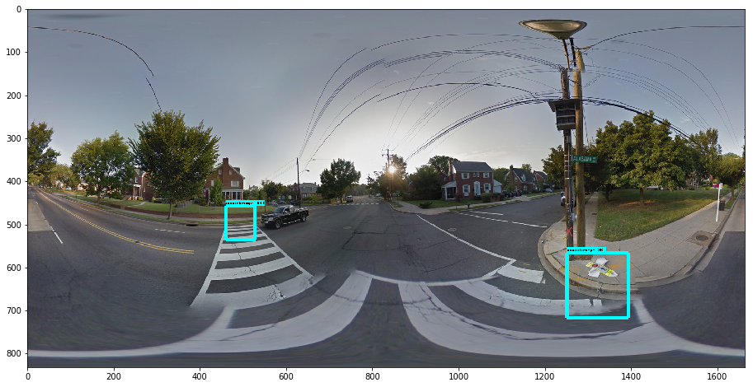

Figure 2

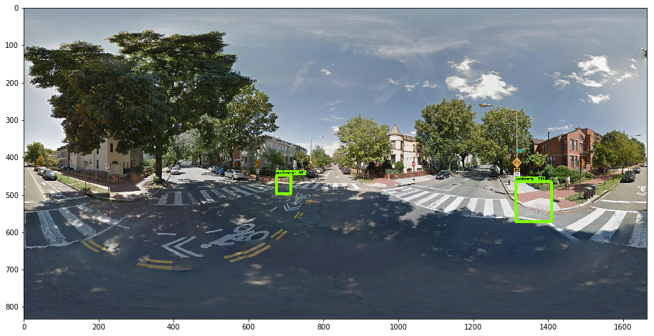

Figure 3

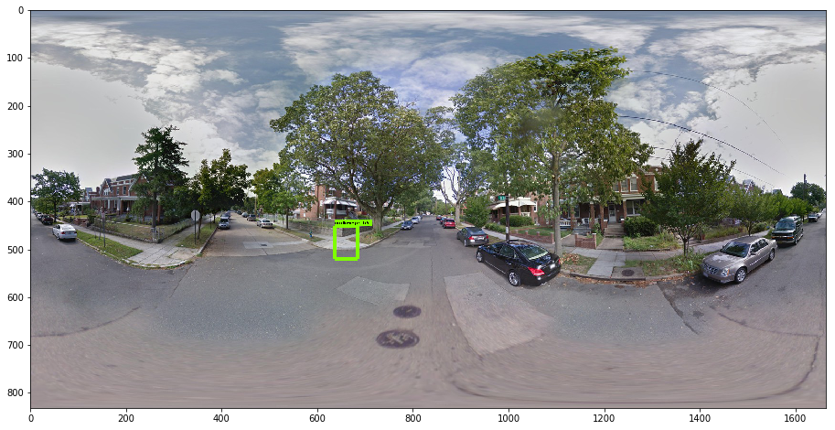

Figure 4

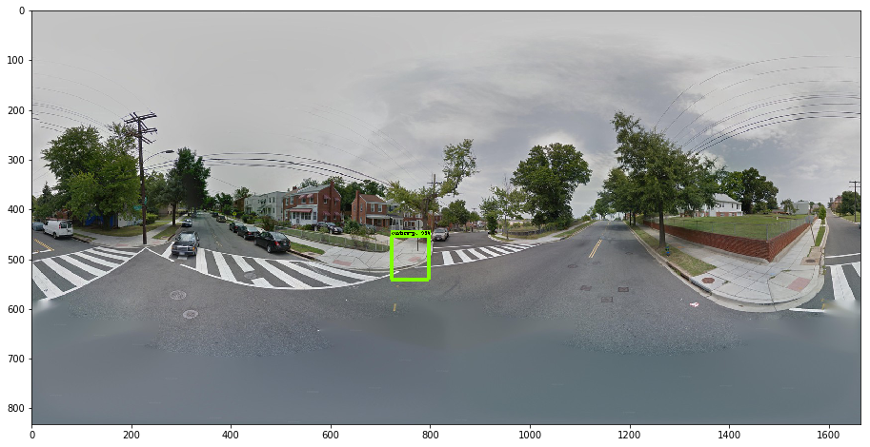

Figure 5

5 Results and Analysis

6 Ethics

The work addressed in this paper is based primarily on Google StreetView panoramic images. As of 2008, Google began to take steps to protect the privacy of people and their property captured on StreetView by blurring faces and license plates found in the image [25]. While the expectation of privacy on a public street is beyond commonly accepted practice, it is a reasonable step that Google has taken to provide added privacy.

The labeled image data sourced from the University of Maryland Project Sidewalk team was created via crowd-sourced labor online. The project solicits unpaid volunteer labor to classify parts of the Street View image via a web interface without compensation.

Lower income neighborhoods may be under-represented in the StreetView image data, or the frequency of image refresh may differ between different streets. If the virtual view provided by StreetView is a conduit to improved infrastructure, steps must be taken to ensure there is equitable representation across neighborhoods in the image set.

No human subject testing was conducted as part of the research in this paper.

7 Future Areas of Research

The development of the algorithm to detect locations of curb cuts is an important step in creating a universe of data about the accessibility level of cities.

.

References

1. Kotaro Hara, Shiri Azenkot, Megan Campbell, Cynthia L. Bennett, Vicki Le, Sean Pannella, Robert Moore, Kelly Minckler, Rochelle H. Ng, and Jon E. Froehlich. 2015. Improving public transit accessibility for blindriders by crowdsourcing bus stop landmark locations with Google Street View: An extended analysis. ACM Trans. Access. Comput. 6, 2, Article 5 (March 2015), 23 pages.
2. Kotaro Hara, Jin Sun, Robert Moore, David Jacobs, Jon E. Froelich. 2014. Tohme: Detecting Curb Ramps in Google Stret View Using Crowdsourcing, Computer Vision, and Machine Learning. UIST ’14, October 5-8 2014. Honolulu, HI.
3. Claus Bahlmann, Ying Zhu, Visvanathan Ramesh, Martin Pelkofer, Thorsten Koehler. “A System for Traffic Sign Detection, Tracking, and Recognition Using Color, Shape, and Motion.” IEEE Xplore, July 2005.
4. Fei-Fei, Li, and Pietro Perona. "A bayesian hierarchical model for learning natural scene categories." *Computer Vision and Pattern Recognition, 2005. CVPR 2005. IEEE Computer Society Conference on*. Vol. 2. IEEE, 2005.
5. Goodfellow, Ian J., et al. "Multi-digit number recognition from street view imagery using deep convolutional neural networks." *arXiv preprint arXiv:1312.6082* (2013).
6. Simonyan, Karen, and Andrew Zisserman. "Very deep convolutional networks for large-scale image recognition." *arXiv preprint arXiv:1409.1556* (2014).
7. Deehr, Rebecca C., and Amy Shumann. "Active Seattle: achieving walkability in diverse neighborhoods." *American journal of preventive medicine* 37.6 (2009): S403-S411.
8. Knopp, Jan, Josef Sivic, and Tomas Pajdla. "Avoiding confusing features in place recognition." *Computer Vision–ECCV 2010* (2010): 748-761.
9. Le, Quoc V. "Building high-level features using large scale unsupervised learning." *Acoustics, Speech and Signal Processing (ICASSP), 2013 IEEE International Conference on*. IEEE, 2013.
10. Richardson, Andrea S., et al. "One size doesn’t fit all: cross-sectional associations between neighborhood walkability, crime and physical activity depends on age and sex of residents." *BMC public health* 17.1 (2017): 97.
11. Hajna, Samantha, et al. "Neighborhood walkability: field validation of geographic information system measures." *American journal of preventive medicine* 44.6 (2013): e55-e59.
12. Hosler, Akiko S., et al. "Relationship between objectively measured walkability and exercise walking among adults with diabetes." *Journal of environmental and public health* 2014 (2014).
13. Clarke, Philippa, et al. "Using Google Earth to conduct a neighborhood audit: reliability of a virtual audit instrument." *Health & place* 16.6 (2010): 1224-1229.
14. Kim, Hyungjin et al. “A Probabilistic Feature Map-Based Localization System Using a Monocular Camera.” Sensors 2015
15. Kelly, Cheryl et al. “The Assoication of Sidewalk Walkability and Physical Disorder with Area-Level Race and Poverty.”
16. Sheppard, Stephen R.J., Cizek, Petr. “The Ethics of Google Earth: From Spatial Data to Landscape Visualization.”
17. Bennett, Sean & Kirby, Ronald & Macdonald, Blair. (2009). Wheelchair accessibility: Descriptive survey of curb ramps in an urban area. Disability and rehabilitation. Assistive technology. 4. 17-23. 10.1080/17483100802542603.
18. Bromley, Rosemary DF, David L. Matthews, and Colin J. Thomas. "City centre accessibility for wheelchair users: The consumer perspective and the planning implications." *Cities* 24.3 (2007): 229-241.
19. Dreiseitl, Stephan, and Lucila Ohno-Machado. "Logistic regression and artificial neural network classification models: a methodology review." *Journal of biomedical informatics* 35.5 (2002): 352-359.
20. Dean, Jeffrey, Greg Corrado, Rajat Monga, Kai Chen, Matthieu Devin, Mark Mao, Andrew Senior et al. "Large scale distributed deep networks." *Advances in neural information processing systems*, pp. 1223-1231. 2012.
21. Abadi, Martín, et al. "TensorFlow: A System for Large-Scale Machine Learning." OSDI. Vol. 16. 2016.
22. Ren, Shaoqing, Kaiming He, Ross Girshick, Jian Sun. "Faster R-CNN: Towards Real-Time Object Detection with Region Proposal Networks." eprint arXiv:1506.01497. 2015
23. Redmon, Joseph, Divvala, Santosh, Girshick, Ross, Farhadi, Ali. "You Only Look Once: Unified, Real-Time Object Detection." eprint arXiv:1506.02640. 2015
24. Liu, Wie, Anguelov, Dragomir, Erhan, Dumitru, Szegedy, Christian, Reed, Scott, Fu, Cheng-Yang, Berg, Alexander C.. "SSD: Single Shot MultiBox Detector." eprint arXiv:1512.02325v5. 2016
25. Shankland, Stephanie. “Google Begins Blurring Faces in Street View.” *CNet,* May 13, 2008.
26. Roberts, Lawrence G. *Machine perception of three-dimensional solids*. Diss. Massachusetts Institute of Technology, 1963.